 | 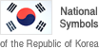 | Cultural  Heritage Administration  NEWS
Division: The National Palace Museum of Korea
Exhibition & Publicity Division
Contact person: Lim Gyeong-hee (02-3701-7631),
Lee Ji-hye (02-3701-7634)

The National Palace Museum of Korea Presents the “Annals of the Joseon Dynasty from the National History Archive on Odaesan Mountain” as the Curator’s Choice for November
- The Significance of the Odaesan Edition of the Annals to Be Presented in the Gallery and Online / Starting October 31-

The National Palace Museum of Korea (Director: Kim In Kyu), an affiliate of the Cultural Heritage Administration of Korea, has selected the edition of the Annals of the Joseon Dynasty that was housed at the National History Archive on Odaesan Mountain as its “Curator’s Choice from the Royal Treasures” for the month of November. In addition to being displayed in the Kings of the Joseon Dynasty permanent gallery on the second floor of the museum, the Odaesan edition will be presented virtually in a YouTube broadcast through the channels of the Cultural Heritage Administration and the National Palace Museum of Korea starting October 31.
* National Palace Museum of Korea YouTube: https://www.youtube.com/gogungmuseum
** Cultural Heritage Administration YouTube: https://www.youtube.com/chluvu

Known in Korean as Joseon wangjo sillok, the Annals of the Joseon Dynasty is a form of national documentary heritage detailing the reigns of Korea’s kings over a period of 472 years (1392 – 1863) spanning from the reign of the first sovereign King Taejo to the twenty-fifth, King Cheoljong. Multiple sets of the annals were produced and separately stored at the Chunchugwan (Bureau of State Records) in Seoul and also at the history archives in Seongju, Chungju, and Jeonju. However, all of the existing copies except the versions stored in Jeonju were lost during the first Japanese Invasion of Korea (1592). Four new editions of the annals were made based on this surviving Jeonju edition. The Jeonju edition and the four newly produced copies were stored at the Chunchugwan in Seoul and in regional history archives established on Manisan Mountain on Ganghwado Island, Myohyangsan Mountain in Pyongan-do Province, Taebaeksan Mountain in Gyeongsang-do Province, and Odaesan Mountain in Gangwon-do Province. The Odaesan edition refers to the copy of the annals that was stored at the archive on Mt. Odaesan situated in Pyongchang, Gangwon-do Province around 1606 (the 39th year of the reign of King Seonjo).

A total of 788 volumes had originally been stored at the National History Archive on Odasesan Mountain. However, only 75 volumes have survived to today. These are currently housed in the National Palace Museum of Korea. The 75 volumes are comprised of nine volumes of the annals of King Sejongjone, 50 on King Jungjong, 15 on King Seonjo, and one on King Hyojong. The volumes that are presented as the Curator’s Choice for November are proofreading copies of the annals of King Seongjong and King Jungjong. These volumes show various proofreading and editing marks, including on the changes to, deletions of, and additions to the letters, and are therefore highly valuable for allowing the observation of the details of the finishing stages of the process of publishing the annals.

The museum may currently be accessed only in accordance with the requirements in place to reduce the potential for the spread of COVID-19. Those who are unable to visit the gallery in person can still enjoy this month’s Curator’s Choice virtually through a video with Korean and English subtitles available on the museum’s website (gogung.go.kr). Our visitors can also see on the YouTube channels of the museum and of the Cultural Heritage Administration of Korea.

Attachment: Images
(Attachment)

Images
Promotional Material for Curator’s Choice – November
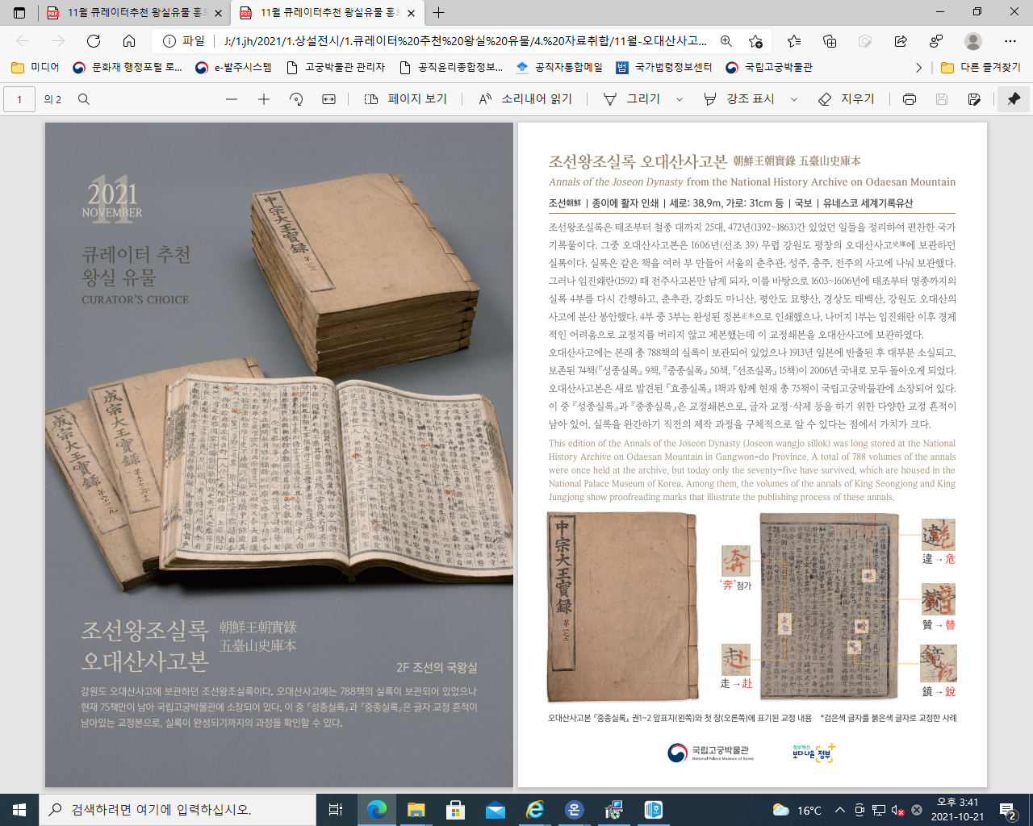
Annals of the Joseon Dynasty from the National History Archive on Odaesan Mountain
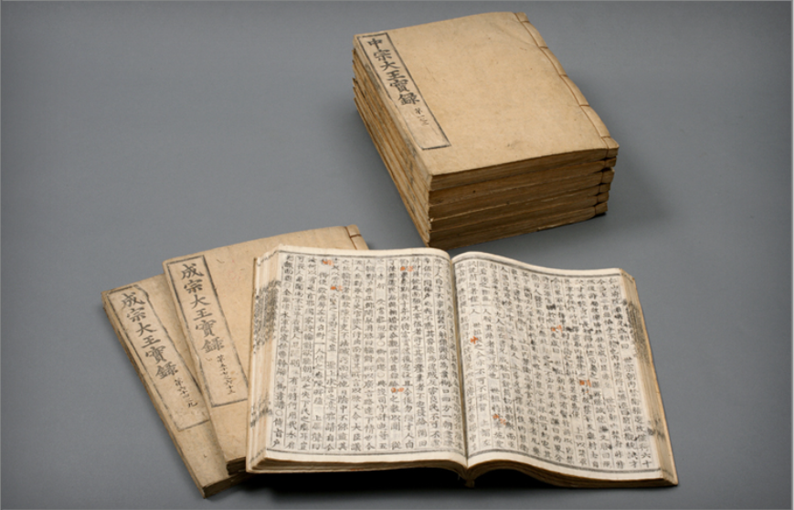

Proofreading and editing marks on volumes 1 and 2 of the annals of King Jungjong of the Odaesan edition
(Example of proofreading marks written in red over black printed letters)
